
SOP Title: | FedEx Returns, Refusals & Tampered Box Claims Processing
Document Storage Location: | STACS/Management/SOPs – Logistics and Warehousing | Document #: | SEASOP435v100
SOP Originator: | Avika Raja | Last Edited by: | Avika Raja
Effective Date: | 08/04/2021 | Last Edited Date: | 08/04/2021
Other: | GMP access required.

- Purpose
  - To develop the Claims process for return shipments to the Coppell Warehouse that are reported as
a tampered box or customer return or refusal.
- Scope
  - Coppell - This process shall be followed if some or all units from the return shipment delivered to the Coppell Distribution Center (DC) are missing or show signs of tampering.
- Responsibilities
  - The SEA eCommerce (eComm) team shall provide daily updates on the returns backlog report to the SEA Logistics, Planning & Shared Services eComm (LPS) team.
  - The SEA eComm team shall be responsible to close out the Return Merchandise Authorization (RMA) once the claim is closed.
  - The LPS team shall keep a record of the RMAs, both delivered and in-transit.
  - The 3PL eComm team shall fill out the FedEx Inspection Report and include pictures of empty or partially empty boxes.
  - The LPS team shall post WC1E to WC41 transactions in GERP before claims are filed with FedEx.
  - The LPS Inventory team shall post inventory adjustment transactions in GERP after claims are filed with FedEx.
  - The LPS Claims (Claims) team shall file and submit the claim to FedEx and Samsung Fire & Marine (SFM) (Samsung insurance company) and shall also submit a PUMI to make the necessary adjustments in the inventory.
- Instructions
Customer Refusals/Tampered Box: Some or all items in package are missing or show signs of tampering.
  - 3PL Returns Associate receives a customer refusal or tampered box.
    - Tampered Box: see Tampered Box SOP for identification details.
    - Partial refusal: some items are missing from the return shipment.
    - Empty RMA (Unsent): all items are missing from the return shipment; the box is empty.
    - Associate should Receive missing/tampered product within 24 hours.
  - 3PL Returns Associate checks RMA to confirm the number of items listed in 3PL WMS matches the number of units in box.
    - If there are discrepancies between the quantities, the associate researches RMA in 3PL WMS.
  - 3PL Returns Associate processes the return/refusal.
(See Returns Processing and Refusals Processing SOPs for details.)
    - Associate makes sure to keep merchandise, original packaging, and any other box contents until Claims resolution process has concluded.
    - Associate processes the return/refusal item as Unsent.
      - Unsent: If the original box is returned but is missing the original items.
  - LPS Returns Manager fills out the FedEx Inspection Report for tampered/missing/unsent content.
    - Take pictures of box with tampered/missing/unsent items.
  - LPS Returns Manager sends the FedEx Inspection Report with pictures to LPS team and Claims team.
    - Kalishar Mitchell (Claims): kmitchell@sea.samsung.com
    - Knia Franklin (Claims): k.franklin@partner.sea.samsung.com
    - Gowtham Sivashanmugam (LPS): g.sivashanmu@partner.sea.samsung.com
    - Emanuel Silva (LPS): e.silva@partner.sea.samsung.com
    - Include Excel file with all daily discrepancies. (Reference ‘Related Documents’ below)
    - Excel file should include delivery order (DO) number, tracking number, material, customer purchase order (PO), and return delivery order (RDO).
  - LPS team moves the missing and/or unsent units from WC1E to WC41.
    - GMP: Missing/tampered product will be transferred from WC1E to S341/WC41 via MB1B transaction with a 311 movement. (Click here for the SOP)
    - WMP: Product will be added into S341/WC41 via MB1C transaction with a 501 movement. (Click here for the SOP)
    - Transfer product to V-EIPAR-21 bin using LT06.
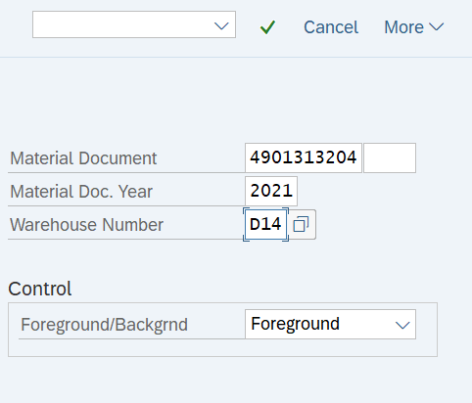
      - Enter ‘Material Document’, ‘Material Doc. Year’, and ‘Warehouse Number’ information into designated fields.

      - Enter ‘Dest.target quantity’, ‘SUT’, and ‘Type’ information into designated fields.
      - Enter ‘V-EIPAR-21’ into ‘Destination Bin’ field.
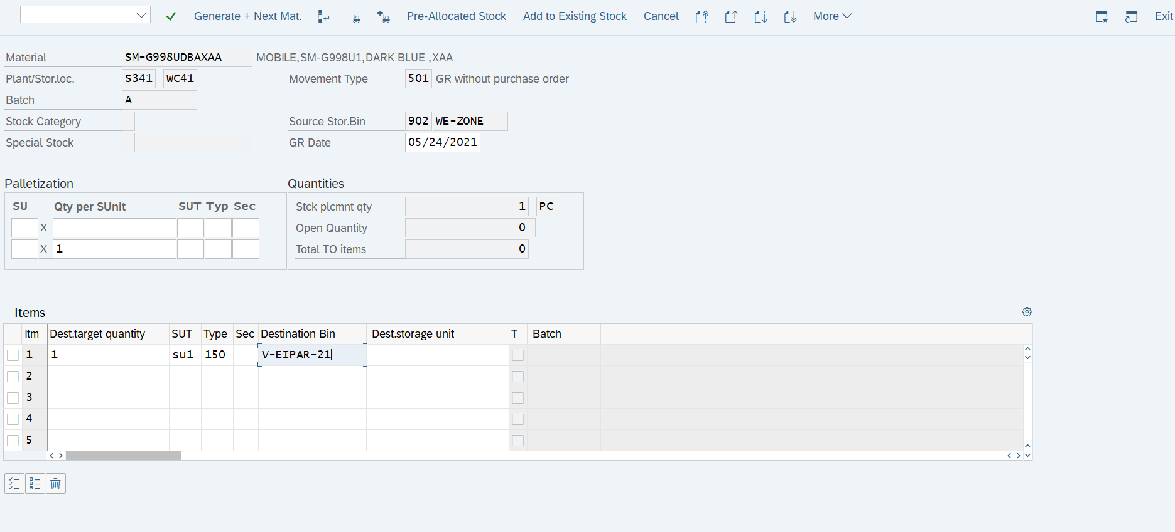

  - For Empty RMA (Unsent): LPS team checks shipping information for the past 28-30 days.
    - LPS team
      - Creates Return Delivery Orders (RDOs) for Unsent material.
      - Receives Unsent material into WC1E.
      - Transfers Unsent material to Claims bin (V-EIPAR-21).
    - SEA eComm team provides return tracking numbers for customer orders.
    - LPS team generates biweekly Samsung_SN _Shipped_Detail_Report .rpt for customer addresses.
      - Report generated via 3PL WMS.
    - LPS team files tracer with FedEx.
  - LPS team notifies Claims team when the transaction is complete.
  - Claims team submits the claim with pictures and the Inspection report to FedEx online.
    - FedEx Representative: janiece.graham@fedex.com
  - Claims team notifies eComm and 3PL teams when FedEx claim resolution process has concluded.
    - Claims resolution process typically takes 7-10 days.
  - Claims team files a claim with the SFM team for any remaining value not covered.
    - SFM team member: Steve.Swenson@WillisTowersWatson.com
    - If full claim amount is under $100, claim is paid by FedEx.
    - If full claim amount is over $100, claim is paid by FedEx and SFM.
  - Claims team submits a PUMI to make the subsequent adjustments in the inventory.
  - When PUMI is approved, LPS Inventory team adjusts the unit(s) out via MB1C transaction and movement type A02. (Click here for the SOP)
  - LPS team updates the status of the RMAs in their record after adjustment is completed.
  - LPS team sends a confirmation email to the SEA eComm team distribution mailing list.
  - SEA eComm team closes out the RMA on their list.
- Related Documents

